6.1.2 Assessment Brief Coversheet
This brief relates to assessment using the following assessment technique
Assignment ☐ Project ☐ Learner Record ☐ Collection of Work ☒ Skills Demonstration ☐

Learner Name/ID:
Programme/ Centre: | Group/ Course Name/Code: |  | Major Award Code:
Kerry College – Clash Campus | Business Studies L5 |  | 5M2102
Module/ Component Code and Title: | Assessment Title/Weighting: |  | Learning Outcomes:
Applied Economics  5N1350 | Alternative to Exam_  Assignment 3 Theory Based  – 40% |  | LO1, 2, 3, 4, 5, 6, 7, 8, 9, 10, 11, 13, 14, 15, 16 & 17
Assessor Name: | Issue Date: |  | Submission Date & Time:
Margaret Burns | Tuesday 4th May, 2021 |  | Monday 10th May, 2021  - 6 pm
Integrated with other Assessments?  No ✔ Yes  If yes give details on the right |  | Assessor(2)
 |  | Module (2)
 |  | Learning Outcomes:

Coursework Brief – Detail/Requirements

Sections A
10 Short Answer Questions
Learners are required to answer all 10 questions (1mark per question)

Section B
6 Structured Questions
Learners are required to answer any 3 questions (10 marks per question)

Section A: Answer all of the following questions (1 mark each)
1. Outline the role of the European Central Bank (ECB). (1 mark)
One of the roles of the European Central Bank is to maintain the price stability and safeguarding the value of the Euro hence this supports the economic growth
2. Briefly explain two benefits of EMU (Economic and Monetary Union) for Ireland.
Monetary union has benefited Ireland through the reduction of the transaction cost in an increasingly integrated regional market.
The monetary union also helped in increasing the price transparency which has increased the inner regional competition and the market efficiency.
(1 mark)

3. What is the role of the Central Bank of Ireland and one of its main responsibilities?
The central Bank of Ireland has a role of serving the public interest by safeguarding the financial and monetary stability and also ensuring that the financial system operates in the best interest of consumers and the entire economy. One of the central Bank’s main responsibility is price stability and financial stability.

(1 mark)
4. Explain the Law of Diminishing Marginal Utility. (1 mark)
The Law of Diminishing Marginal Utility states that with all else constant, as the consumption increases, the marginal utility that is derived from every additional unit declines.
5. What does the Law of Demand state? (1 mark)
The law of Demand states that with all other factors being constant, price and quantity are inversely related such that the higher the price of a good the lower the demand and the lower the price of a good the higher the demand.
6. The Supply function is represented as follows: Sy = f (Py, Pr, C, T, U, Cr., G).
Explain each element in the function. (1 mark)
Py-The price consumers are offering for Good Y
Pr- The price of related goods
C- the cost of producing Good Y
T- Technology used to produce Good Y
U- Unplanned factors. These are events outside the control of the producer, and can have either a positive or a negative effect
Cr- Availability of credit. Firms require credit from banks in order to set up and expand and hence supply the market.
G- Government. The government can offer incentives to promote a desirable product

7. Explain Elasticity.
Elasticity is used in measuring the change in the quantity demanded of a good or a service in relation to its price movements. (1 mark)
.
8. Explain two factors that affect Price Elasticity of Demand (PED) (1 mark) The price of the Good- The elasticity of demand for a good depends on the price of that good. This means that the smaller the price of a good, then the lesser the elasticity of its demand. On the other hand, the larger the price of a good, then the more or the higher the elasticity of demand
Availability of substitutes- If close substitutes for a particular good are available in the market, then the demand for the good would be relatively more elastic.
9. List two characteristics of Imperfect Competition. (1 mark)
Imperfect competition comprises of small number of sellers and buyers.
Imperfect competition comprises of high barriers to entry and exit

10. Explain what is meant by Privatisation, and list one advantage of the privatisation of state assets. Privatisation of state assets means selling of state-owned assets to the private sector particularly because private sector tends to run businesses more efficiently because they are driven by profit motives. Privatisation offers numerous advantages. One of the advantages of privatisation is reducing the interference and indulgence of the state in the activities of the company thus increasing efficiency and profitability.
(1 mark)
(Total 10 Marks)

SECTION B: Answer any 3 of the following questions.

Question 2.

“The World Trade Organisation (WTO) is the only international organisation dealing with the global rules of trade between nations.”
(1) Outline two economic benefits claimed for ‘free trade’. (2 marks) free trade means that countries can engage in trade without the no tariff barriers or non-tariff barriers to trade.
Two economic benefits for free trade include.
- Economies of scale. When countries specialise in certain goods they are able to benefit from economies of scale and lower average costs particularly the industries with high fixed costs and those that require high investment levels. The economies of scale will lead to lower prices for consumers and great efficiency for the exporting firms.
- Comparative advantage- free trade enables countries to specialise in goods where they have a comparative advantage.

(2) Outline three reasons why countries might choose to impose barriers to free trade.
Countries may choose to impose barriers to free trade in order to;
- Protect infant industries that do not have economies of scale that the matured competitors from other countries possess. Such industries therefore require to be sheltered under the government protection until they reach a level where they can compete with these already matured competitors.
- Defending national security- the trade barriers may be imposed to protect certain industries that are regarded as tactically important for safeguarding the national security particularly defence industries.
- protecting domestic employment- trade barriers to free trade may be imposed t protect domestic jobs that could arise from the possibility of heightened competition from imported goods
(3 marks)
(3) What is the Law of Absolute Advantage? Give an example of a country that has one? (2marks)
The Law of Absolute Advantage is described as the ability of an individual, region, company or a country to produce a greater quantity of a good or service using the same quantity of inputs per unit of time or producing same quantity of good or service per unit of time using a lesser input quantity compared to another entity that produces the same good or service. One country that has an Absolute Advantage is the Canadian economy. Canada is rich in low-cost land and thus has an absolute advantage in agricultural production as it can produce it more efficiently relative to other countries.
(4) Explain three assumptions underlying the Law of Absolute Advantage. (3 marks) (10 marks)
The assumptions of Law of Absolute Advantage include;
- assumption that the factors of production lack mobility and thus cannot move between countries.
- Assumption that there is trade balance such that the exports must be equal to imports. Therefore, there cannot be trade deficits, surplus and trade imbalances.
- Assumption that there are no trade barriers to trade. Trade barriers tend to be imposed by governments in order to restrict or discourage the exportation and importation of particular goods or services.

Question 4.
A. A firm operating under conditions of Perfect Competition is a ‘price taker’.
(1) Explain the concept of being a ‘price taker’. (1 mark)
A price taker is a producer or rather a market participant who is not able to dictate the prices in a market. Therefore, the price taker must accept the prevailing market price.
(2) Explain, with the aid of a labelled diagram, the equilibrium position of a firm in short run Perfect Competition.
In the short run, a firm will possibly make an economic profit. It is also possible to mane zero or negative economic profits. When the price is higher than the average total cost, the firm will make a profit. When the price is lower than the average total cost, the firm will make a loss.
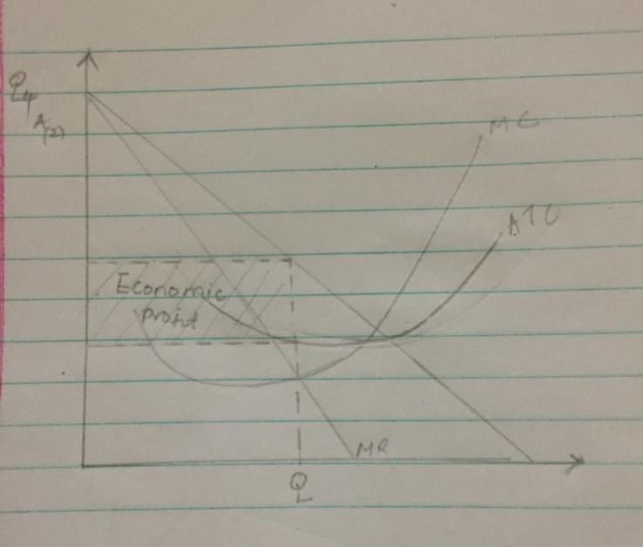
B. With the aid of a labelled diagram(s), explain the impact which the entry of new firms would have on the Market/Industry and on the equilibrium position of this Firm.
More firms enter the perfect competition market due to the supernormal profits. However, as the new firms enter the market, it is difficult to sustain the economic profit. Demand curve of each firm shifts downward and the price falls to P1. The profits will be maximised at Q1 and normal profits will be made were AR=AC.
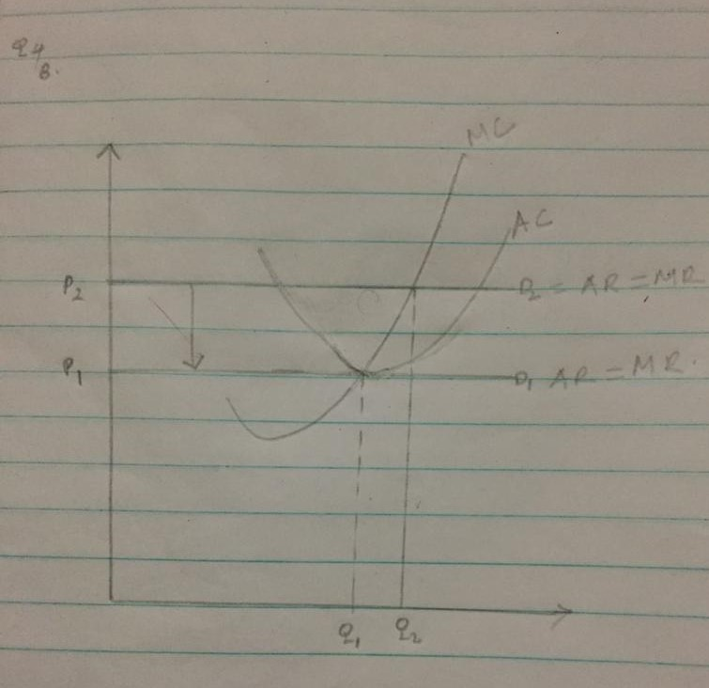

Question 5.
A. In order to achieve its objectives the Government has many tools or policies at its disposal, e.g.
- Fiscal Policy
- Legislation
- Market Intervention
- Social Partnership
- Exchange Rate Policy
- Monetary Policy
Choose four from the above list and discuss how each policy can be used to achieve government objectives. Fiscal policy
Fiscal policy is used by the government to adjust its spending levels and tax rates in order to monitor and influence the economy of a country. Fiscal policy stimulates the economy in different ways through either expansionary or contractionary policy so as to either increase economic growth through spending and taxes through expansionary policy or to slow economic growth and decrease inflation through contractionary policy.

Monetary policy
Monetary policy is used to achieve several goals and objectives such as maintaining a high economic growth rate, achieve and maintain full employment, controlling inflation, stabilizing prices and wages and maintaining long term interest rates. The Federal Reserve implements monetary policy to regulate money supply through three main instruments; open market operations, reserve requirements and discount rate.
Market intervention
Market intervention involves actions taken by the government or public entity which affect the market economy. The market intervention by the government is useful in combating the market inequalities. The government intervenes through taxation, regulation and subsidies. Government may also intervene in markets in order to promote general economic fairness as well as maximize the social welfare.
Exchange rate policy
Exchange rate changes have macroeconomic effects of the economy of a nation and therefore countries need to think about which exchange rate policy is best to adopt. Exchange rate policy affects aggregate demand due to its effects on imports and exports and therefore policy makers can exploit this connection. Exchange rates need to be held down so as to stimulate exports and pushed up in order to reduce inflationary pressure.
(6 marks)

B. State and explain what you consider to be the three most important economic aims of the Irish Government.
Achieve Full Employment: Pursue policies which will improve our competitiveness, boost exports and so help create jobs in Ireland.
2) Achieve moderate Economic Growth: The government must try to manage current downturn in economic activity and ensure that we return to a position of some economic growth. Appropriate fiscal policy may help towards achieving this.
3) Control Government Finances: The government must continue to reduce spending. It must also widen the tax base so as to increase taxation revenues. These measures will help reduce borrowing and help reduce the national debt

Submission Details
Your work must be submitted to your course teacher/ tutor/ instructor and on or before the due date.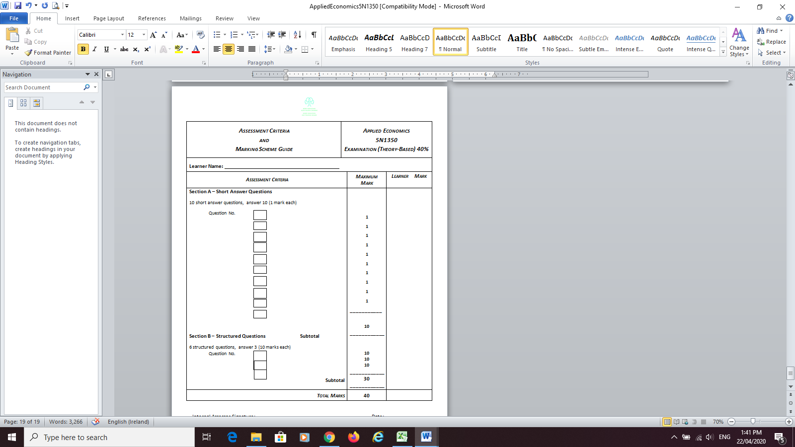

Page 1 of 2

6.1.2 Assessment Brief Coversheet
Please complete this and include it with your work when you are submitting it to your teacher/tutor/instructor for assessment

Declaration  I am signing this to confirm that: |  |  |  | TICK P
- This is my own work |  |  |  | x
- I understand that passing someone else’s work off as my own, without referring to it or getting their permission is called malpractice. |  |  |  | x
- I understand that if there is a doubt about this work being my own it can be investigated and if found to be malpractice I may not receive certification. |  |  |  | x
- I am aware that Kerry ETB has an Assessment Malpractice policy and an Assessment Deadline policy which applies to me. |  |  |  | x
Learner Signature |  | Date:

Dates Feedback
I received Feedback on this assessment:  Date / Ongoing | Where Evidence of Feedback is Found | Learner Signature | Teacher/Tutor/Instructor Signature
 | Via Microsoft Teams Spreadsheet |  | Margaret Burns

Details of evidence: Written ☐ Verbal ☐ Recorded ☐

Page 2 of 2

